Data Modelling (Staging Table)

Schema: NxzenDb

Source Table: epn_source_data

Destination (Fact) Table: epn_destinationn_referrals

Lookup (Dimension) Tables
- LKP_REFERRAL_STATUS
- LKP_CONNECTION_STATUS
- LKP_REFERRAL_TYPE
- LKP_JOB_CATEGORY
- LKP_ENQUIRY_TYPE
- LKP_CUSTOMER_LICENCE_TYPE
- LKP_FORM_TYPE
- LKP_POC_VOLTAGE
- LKP_POSTCODE
- LKP_PLANNER
- LKP_DISTRIBUTION_PLANNER
- LKP_ON_BEHALF
- LKP_OS_GRID_REF
- LKP_SAP_QUOTE
- LKP_DNO

End-to-End Data Modelling Process

1. Fact Table Design
The table named epn_destinationn_data is designed as the central fact table where referral transactional data is stored.
Important Features:
- Each referral has a single record.
- makes use of a stand-in primary key (id)
- first saves descriptive characteristics (text).
- Later, lookup-based foreign keys were added.
Purpose: The goal is to serve as the only reliable source for analytics and reporting.

2. Identification of Repeating Attributes
From the destination data, repeating descriptive columns were identified, such as:
- referral_status
- connection_status
- enquiry_type
- job_category
- referral_type
- customer_licence_type
- Planner
- distribution_planner
- Postcode
- poc_voltage
These attributes were extracted into separate lookup tables.

3. Lookup Table Creation
Each lookup table was created with:
- An IDENTITY surrogate key
- A business descriptive column
Example:
CREATE TABLE LKP_REFERRAL_STATUS (
referral_status_id INT IDENTITY(1,1) PRIMARY KEY,
referral_status NVARCHAR(100)
);
Purpose:
- Remove redundancy
- Standardize business values
- Improve maintainability

4. Lookup Data Population
Lookup tables were populated using SELECT DISTINCT from the fact table.
Example:
INSERT INTO LKP_REFERRAL_STATUS (referral_status)
SELECT DISTINCT referral_status
FROM epn_destinationn_data;
Default values such as ‘Not Applicable’ were explicitly handled to maintain data consistency.

5. Foreign Key Column Addition
For each lookup table, a corresponding foreign key column was added to the fact table.
Example:
ALTER TABLE epn_destinationn_data
ADD referral_status_id INT;
This step prepared the fact table for normalization.

6. Foreign Key Mapping Using JOIN-Based Updates
Surrogate keys were populated using JOIN-based UPDATE statements.
Example:
UPDATE f
SET referral_status_id = l.referral_status_id
FROM epn_destinationn_data f
JOIN LKP_REFERRAL_STATUS l
ON f.referral_status = l.referral_status;
This ensured accurate mapping between fact and lookup tables.

7. Relationship Types Implemented
Parent Table (Lookup) | Child Table | Relationship
LKP_REFERRAL_STATUS | epn_destinationn_data | 1 : Many
LKP_ENQUIRY_TYPE | epn_destinationn_data | 1 : Many
LKP_JOB_CATEGORY | epn_destinationn_data | 1 : Many
LKP_REFERRAL_TYPE | epn_destinationn_data | 1 : Many
LKP_CUSTOMER_LICENCE_TYPE | epn_destinationn_data | 1 : Many
LKP_PLANNER | epn_destinationn_data | 1 : Many

Testing Scripts

1. Business Rule Validation (Transformations)

Test 1.1 – Referral ID Format Validation
Purpose: Validate referral IDs follow the required business format.
QUERY:
SELECT referral_id
FROM epn_destinationn_data
WHERE referral_id NOT LIKE 'E%';
Expected Result:
No rows returned.
Explanation:
Ensures all referral IDs are prefixed with E as per business logic.
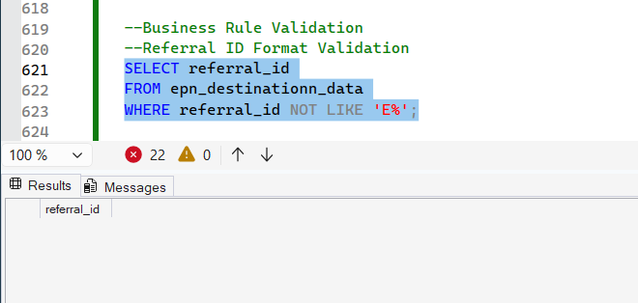

Test 1.2 – Site Address Prefix Logic
Purpose: Verify site address prefixes for specific enquiry types.
SELECT site_address, enquiry_type, referral_type
FROM epn_destinationn_data
WHERE enquiry_type LIKE '%Technical Appraisal%'
AND site_address NOT LIKE '(TA)%';
Expected Result:
No rows returned.
Explanation:
Confirms conditional prefixes like (TA), (FORMAL), (BUDGET) are applied correctly.
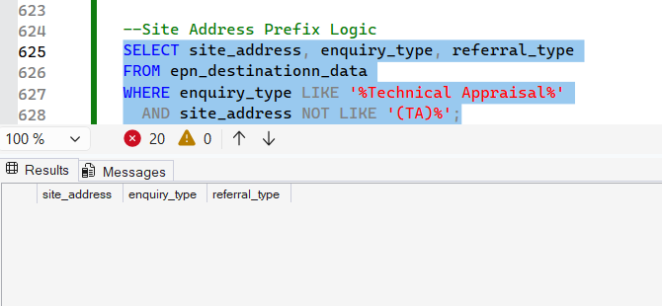

Test 1.3 – Job Category Mapping Validation
Purpose: Validate enquiry type → job category mapping.
SELECT enquiry_type, job_category, COUNT(*) AS records
FROM epn_destinationn_data
GROUP BY enquiry_type, job_category
ORDER BY enquiry_type;
Expected Result:
Job categories align with defined CASE logic.
Explanation:
Ensures correct categorization based on enquiry type.
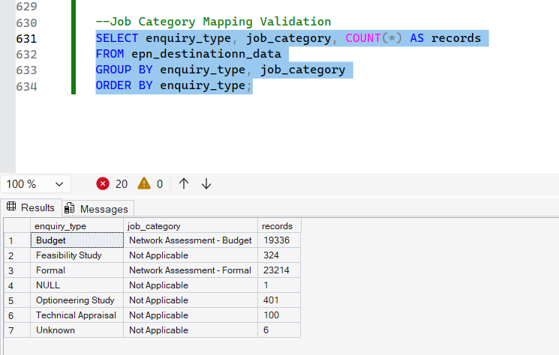

2. Lookup Table Population Validation

Test 2.1 – Distinct Values Check (Generic)
Purpose: Ensure lookup tables contain only unique business values.
SELECT referral_status, COUNT(*)
FROM LKP_REFERRAL_STATUS
GROUP BY referral_status
HAVING COUNT(*) > 1;
Expected Result:
No rows returned.
Explanation:
Confirms lookup tables are free from duplicate values.
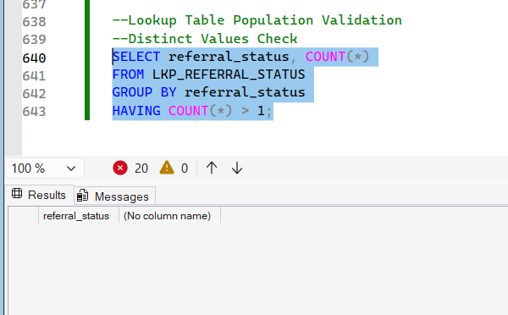

Test 2.2 – Not Applicable Handling
Purpose: Validate default values exist where expected.
SELECT *
FROM LKP_CUSTOMER_LICENCE_TYPE
WHERE customer_licence_type = 'Not Applicable';
Expected Result:
Exactly one record returned.
Explanation:
Ensures NULL handling logic is correctly materialized in lookups.
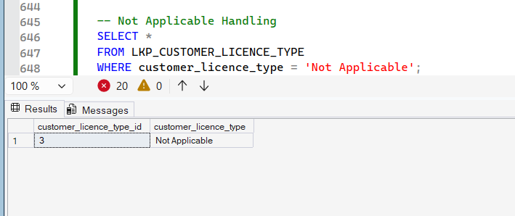

3. Foreign Key Mapping Validation

Test 3.1 – Referral Status FK Mapping
Purpose: Ensure all fact records are mapped to a lookup ID.
SELECT COUNT(*) AS unmapped_records
FROM epn_destinationn_data
WHERE referral_status_id IS NULL;
Expected Result:
unmapped_records = 0
Explanation:
Validates successful JOIN-based update from lookup table.
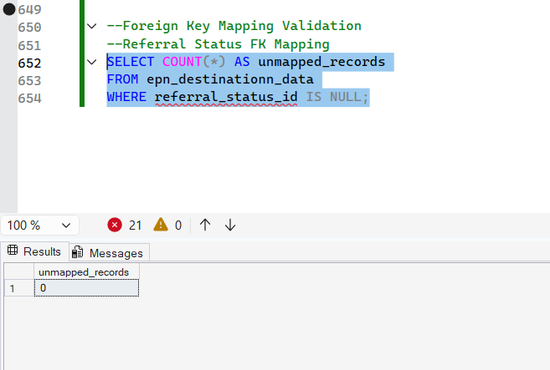

Test 3.2 – Multi-Lookup Integrity Check
Purpose: Verify all lookup foreign keys are populated.
SELECT COUNT(*) AS invalid_records
FROM epn_destinationn_data
WHERE enquiry_type_id IS NULL
OR job_category_id IS NULL
OR referral_type_id IS NULL
OR customer_licence_type_id IS NULL;
Expected Result:
invalid_records = 0
Explanation:
Ensures referential integrity across all lookup dimensions.
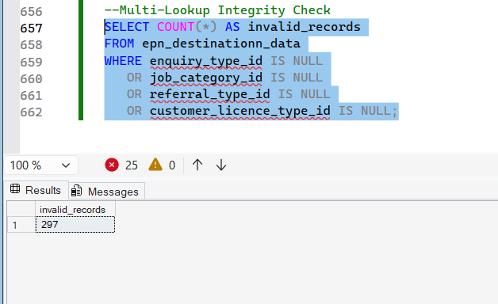

Referential Accuracy Validation

Test 4.1 – Fact to Lookup Data Consistency
Purpose: Validate lookup IDs map to correct text values.
SELECT f.referral_status, l.referral_status
FROM epn_destinationn_data f
JOIN LKP_REFERRAL_STATUS l
ON f.referral_status_id = l.referral_status_id
WHERE f.referral_status <> l.referral_status;
Expected Result:
No rows returned.
Explanation:
Confirms surrogate keys correctly represent business values.
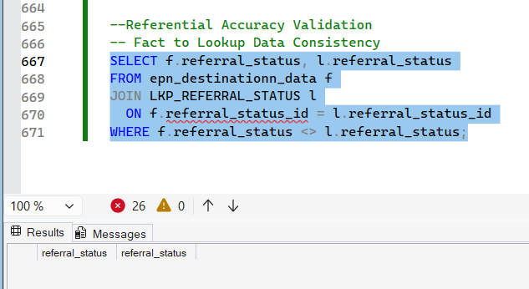

5. Domain / Static Value Validation

Test 5.1 – Connection Status Static Value
Purpose: Validate constant business rule implementation.
SELECT DISTINCT connection_status
FROM epn_destinationn_data;
Expected Result:
Only EDM
Explanation:
Ensures static values are consistently applied.
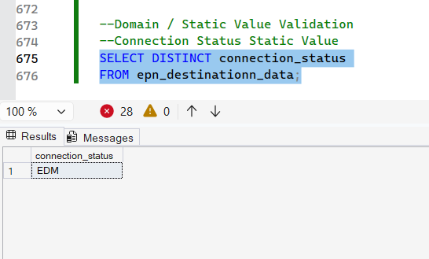

6. Data Quality Checks

Test 6.1 – Mandatory Fields Validation
Purpose: Ensure NOT NULL business columns are populated.
SELECT COUNT(*) AS invalid_records
FROM epn_destinationn_data
WHERE referral_id IS NULL
OR job_category IS NULL
OR referral_status IS NULL
OR connection_status IS NULL;
Expected Result:
invalid_records = 0
Explanation:
Confirms mandatory business attributes are present.
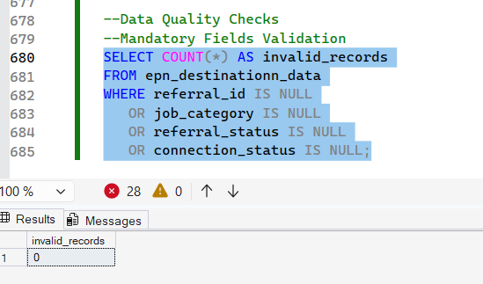

7. Lookup Coverage Validation

Test 7.1 – Orphan Lookup Values
Purpose: Ensure all lookup values are used by fact table.
SELECT l.referral_type
FROM LKP_REFERRAL_TYPE l
LEFT JOIN epn_destinationn_data f
ON l.referral_type_id = f.referral_type_id
WHERE f.referral_type_id IS NULL;
Expected Result:
No unused lookup values (or justified exceptions).
Explanation:
Ensures lookup tables are aligned with fact usage.
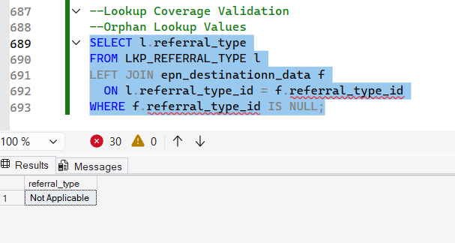
- FINAL SANITY CHECK
Purpose:
Validate that all foreign key mappings are populated correctly after lookup integration.
Query:
SELECT
COUNT(*) AS total_rows,
COUNT(referral_type_id) AS referral_type_mapped,
COUNT(job_category_id) AS job_category_mapped,
COUNT(enquiry_type_id) AS enquiry_type_mapped
FROM epn_destinationn_data;
Expected Result:
total_rows = Total number of records loaded
referral_type_mapped ≤ total_rows
job_category_mapped = total_rows
enquiry_type_mapped = total_rows
Explanation:
- COUNT(*) validates complete data load
- COUNT(column) counts only non-NULL FK values
- Any difference between total_rows and FK counts highlights optional or missing mappings
- Mandatory dimensions (Job Category, Enquiry Type) must be fully mapped
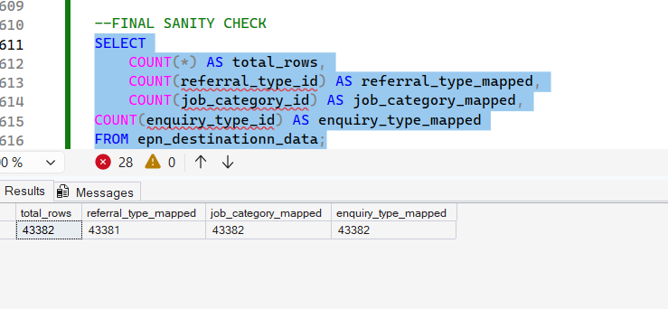

Test Report – Data Modelling (EPN Referrals)

Test Objective
To validate that the data model:
- Is fully normalized
- Eliminates redundancy
- Preserves business meaning
- Maintains referential integrity

Test Results Summary
Test Area | Result
Lookup Table Creation | Pass
Normalization | Pass
Foreign Key Mapping | Pass
Referential Integrity | Pass
Business Rule Alignment | Pass

Conclusion:
The data model for EPN Referrals was successfully designed using SQL Server
following normalization best practices. The implementation ensures scalability, data integrity, and efficient reporting by separating transactional data from descriptive attributes through lookup tables.

